EXERCISES TINY TALK 1A FOR THE FIRT GRADERS
Unit 1 : Hello

I/ Period1+ 2 : (Viết theo mẫu)

1/ Hi, Hi , _________,___________,___________,__________.
- Xin chào ,_______________,_______________,______________,_____________.
2/ Hello , Hello .___________.____________.____________
-Xin chào ,_______________,_______________,______________,_____________.
4/ I’m Benny ._____________,______ ________,______________.
-Tôi là Benny , ___________________,__________________,_________________.
5/ I’m _______ .I’m _______ .I’m _________ .I’m _________
-Tôi là___________, _______________,__________________,_________________.
Unit 2 : Good morning.
Period1: 1( Look and write in the form: Viết theo mẫu)

1/ My name’s Sue , My name’s Sue. My name’s Sue.
__________________,__________________,____________________.
2/ My name’s Benny , My name’s Benny , My name’s Benny .
___________________,__________________,___________________
3/ Miss Dolly , Miss Dolly , Miss Dolly , Miss Dolly .
______________,______________,_______________,_____________.
4/ My name’s_______ , My name’s_______ , My name’s________.
____________________,___________________,___________________.

Period 2: Fill in the blanks: ( Điền vào chỗ trống các câu sau)
1/ M_ n_me’s S_e. ( Tên của tôi là Sue)
2/ My na__e’s B_nn_. ( Tên của tôi là Benny)
3/ G_ _ d morn_ng. ( Chào buổi sáng).
4/ M_ss D_ll_. ( Cô Dolly).
Unit 3 : : GIRLS AND BOYS

Period1: 1( Look and write in the form: Viết theo mẫu)
1/ Good ________ Tom ! 2/ _______ morning Jerry!
3/ H_ _ a_ _ y_ _ ? 4/ F_n_, th_n_ y_ _.
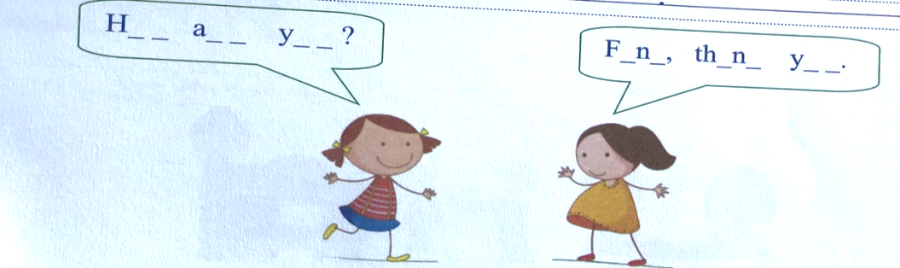

Period 2: Write in the form (Viết theo mẫu)

1/ My name’s ______. My name’s ______. My name’s ______.
___________________,___________________,___________________.
2/ I’m a girl ,______________,________________,______________.
___________________,___________________,___________________.
3/ How are you? , How are you? ,______________________?
__________________? ___________________? ___________________?
4/ Fine, thank you. Fine, thank you, Fine, thank you,
____________________,________________,______________________
5/ Good morning Good morning
___________________,___________________,____________________

Unit 4: IN THE CLASSROOM
New words; ( Từ mới)
1/ a book : 1 quyển sách
2/ a puppet: 1 con rối
3/ a crayon: 1 bút chì sáp
4/ Thank you: Cám ơn
5/ You’re welcome! Không có chi.

Period 1: Look and write: ( Nhìn tranh và viết)
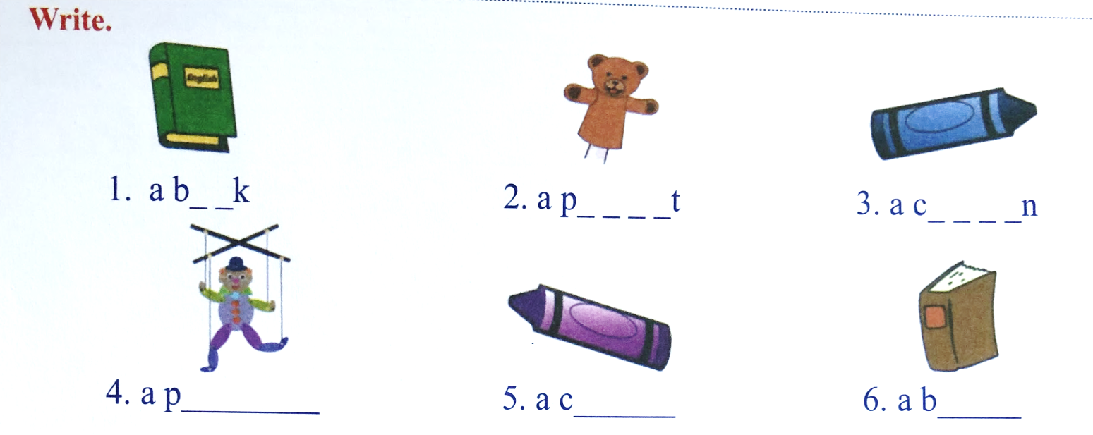
2/ Circle the correct pictures( Khoanh tròn tranh đúng)
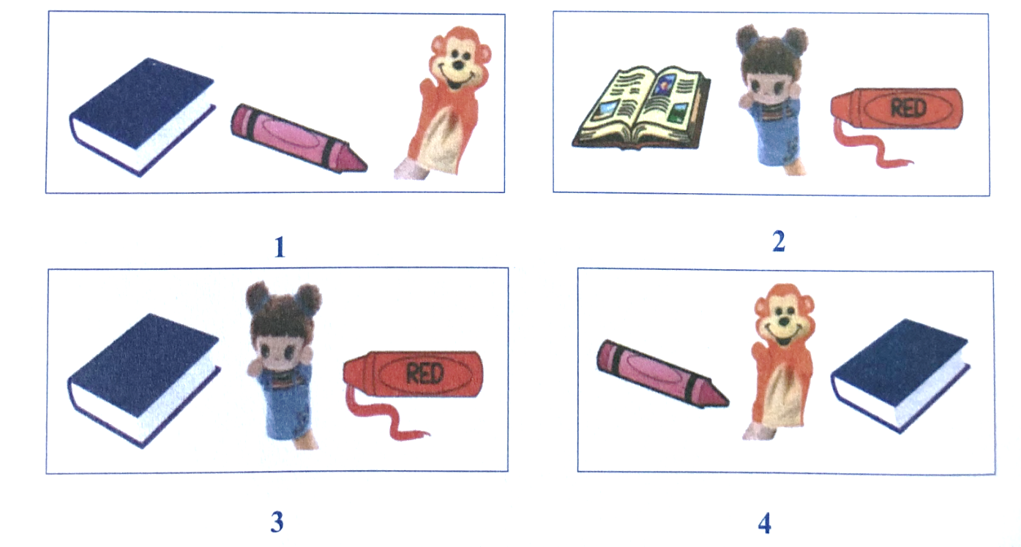
A crayon
A book
A crayon
A puppet

Period 3: Write in the blanks: ( Điền vào chỗ trống)
1/ a b_ _k.
2/ Th_nk y_u.
3/ Y_u’re Welc_me.
4/ a cr_yon.
5/ a P_pp_t.

UNIT 5: MORNING EXERCISES

New words: ( Từ mới)
1/ Up ! lên
2/ Down ! : Xuống
3/ Turn around ! Quay một vòng.
4/ Jump ! Nhảy
5/ Ouch ! ui da!
6/ I’m sorry ! Tôi xin lỗi.
.Period 1: Write( Viết)

1/ Up ! ____.____ .______._____._____._______.____._____.
2/ Down ! __________.___________.____________.___________.
3/ Turn around! ______________,______________,_____________.
4/ Jump ! ________.____________.___________._____________.
5/ Ouch ! __________.__________.___________.______________.
6/ I’m sorry.______________.________________.______________.
Period 2: Fill in theblanks: ( Điền vào chỗ trống)
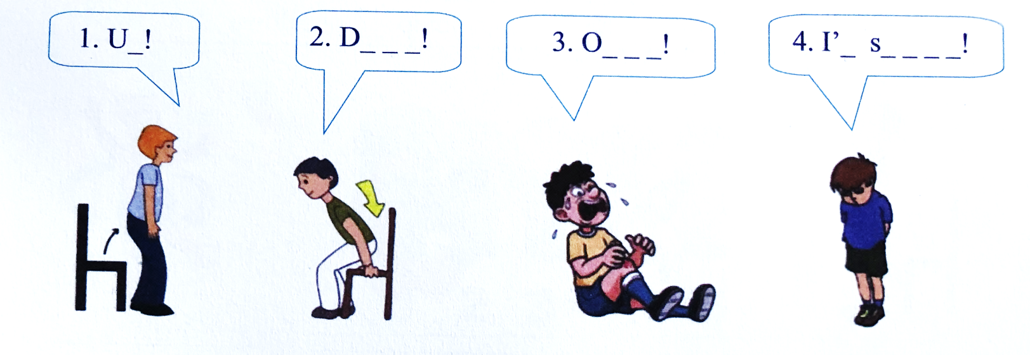

Sit down! - stand up! - Jump ! - Turn around !
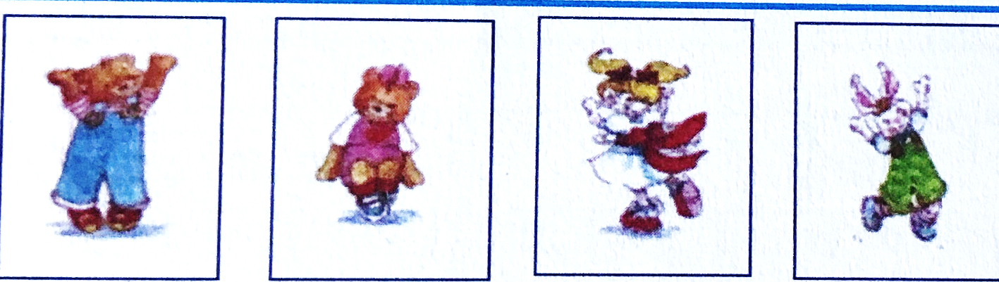
1.Stand up ! 2. Sit _ _ _ _! 3. Turn _ _ _ _ _ _ ! 4. J_ _ _ !

Period :3 Write ( Viết)
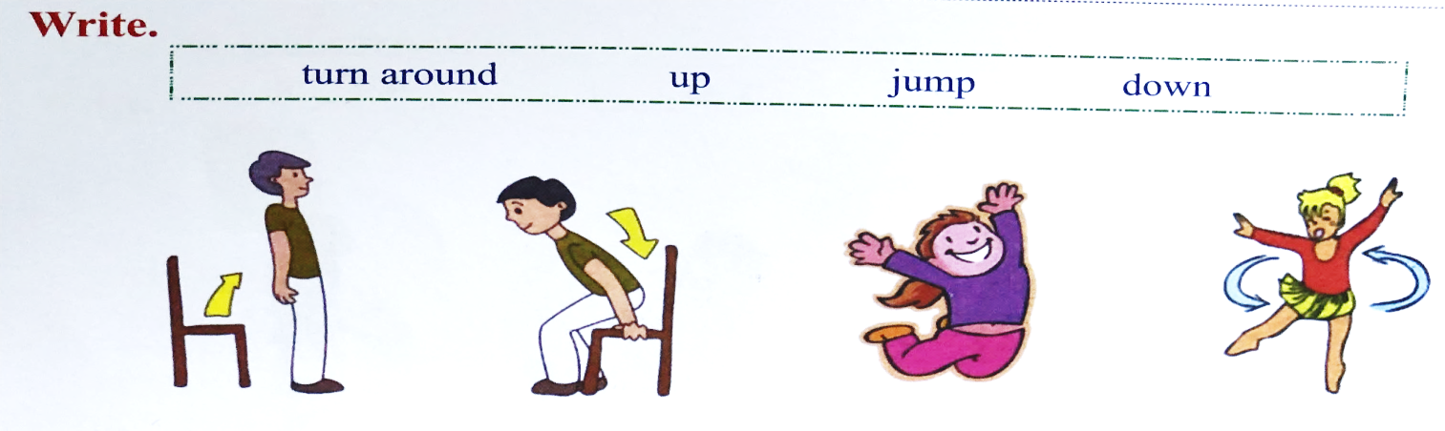
1._______ ; 2._________ ; 3. _________; 4________;

