ÔN TẬP TIẾNG ANH LỚP 2
2019- 2020
Hs viết lại các từ đã học theo chủ đề cho thuộc lòng cách đọc và viết.
( dùm bảng con hoạc giấy nháp)
Bài 1: The weather.
Sunny
Raining
Snowing
Windy
Hot
Wet
Cold
Cool

It’s sunny.
I’m hot.

It’s snowing.
I’m cold.

It’s raining.
I’m wet.

It’s windy.
I’m cool.

Bài 2 : Lunchtime.

Chicken
Noodles
Soup
Hungry
Good.

I’m hungry
Have some soup.
Mmm. It’s good..

I’m hungry
Have some chicken.
Mmm. It’s good..

I’m hungry
Have some noodles.
Mmm. It’s good.

MINI TEST 1

Through tests help us to know Ss grasp the knowledge of what

TEST
I. Match: (kết nối )
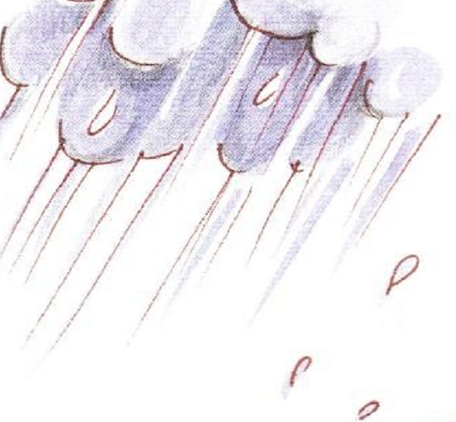
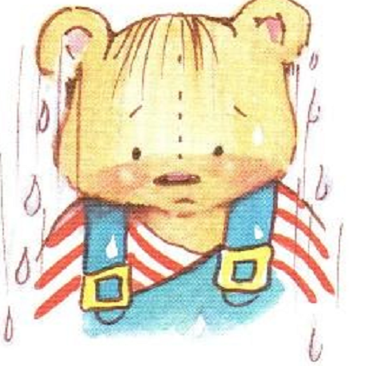


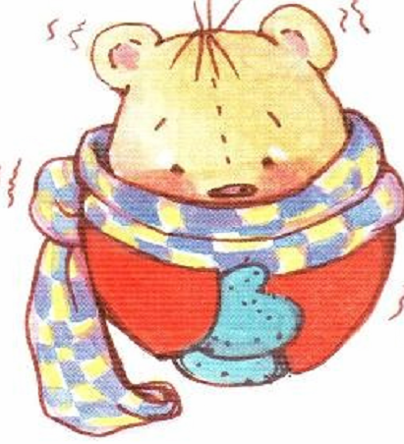


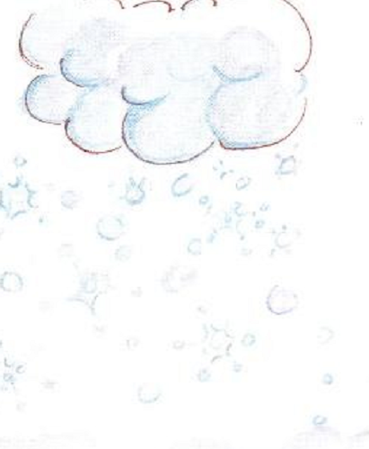

II. Check :( Chọn từ đúng với mỗi hình.)

hot  hot 
cold  raining 

snowing  sunny 
snowing  cold 

III. Complete:( Điền chữ cái để có các từ đúng )
e
u
o
i

H__t W_t

Ra_ning S_nny

MINI TEST 2
- Listen and number :3ms

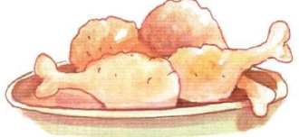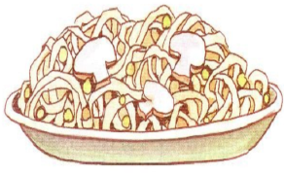

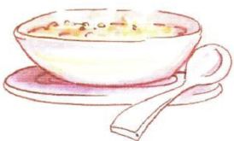
II. Reorder the words to make sentences ( 3ms)
1. hungry / I’m.
________________________.

2. some / Have / chicken.
_______________________.

3. good / It’s.
_______________________.

III. Match :( 2ms)
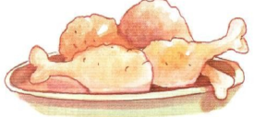 soup

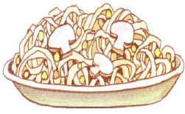 noodles

chicken

IV. Complet:(2ms)

Ha_e s_m_ s_up. ………………………………………

Bài 3: Naptime.

Pillow
Bear
Blanket
Quiet

That’s my pillow.
No! It’s my pillow.
Shh! Be quiet!

That’s my bear.
No! It’s my bear.
Shh! Be quiet!

That’s my blanket.
No! It’s my blanket.
Shh! Be quiet!

Mini Test 3

I/ Listen anh check: (4ms)
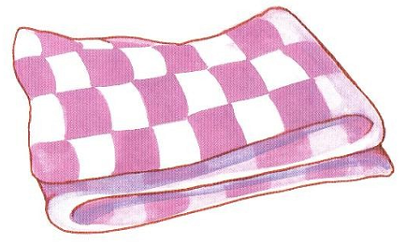 | 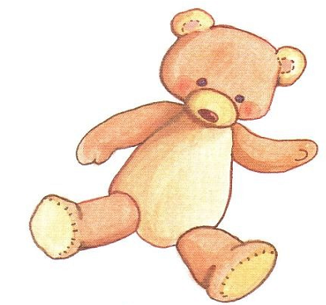
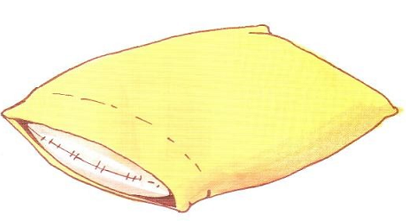 | 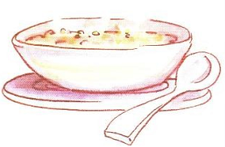

II/ Unscramble:(2ms)

1/ lilwop |  | _______________________
2/ pamiet | 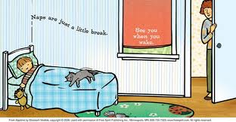 | _______________________
3/ rabe |  | _______________________
4/ Be tiequ |  | _______________________
III/ Reorder the words to make correct sentences:(4ms)
1/ That’s / bear / my / . / |  | _______________________
2/ bear / It / my / ‘s / No! / . / |  | _______________________
3/ quiet! / Shh! / Be |  | _______________________
4/ pillow / my /’s / That / . / |  | _______________________

UNIT 4 : IN TOWN

- Light.
- Go.
- Stop.
- Police officer.
- Farmer.
- Doctor.
- Green light.
- Red light.
She’s a police officer.
- He’s a farmer.
- She’s a doctor.

Mini Test 4

I. Listen and circle
1. 2.
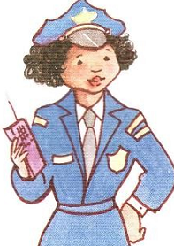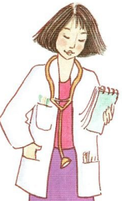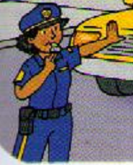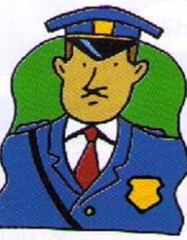
a b a b
- Reorder the words to make sentences

1. He / a / ’s / officer / police / . /
_____________________________

2. farmer / a / ’s / She / . /

_____________________________

3. light / Red / Stop / . / ! /
_____________________________

III. Match

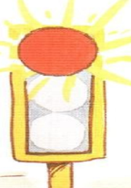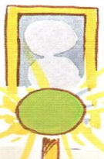

Red light. Green light. Stop! Go! Yellow light.

IV. Write
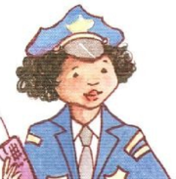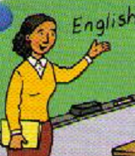
----------------- -------------- ------------- ----------

UNIT 5: SHOPPING

1/ Raining.  2/ Hot.  3/ Snowing.  4/ Wet.  5/ hot.  6/ Cold.  7/ Chicken.  8/ Soup.  9/ Noodles. | 10/ Pillow.  11/ Blanket.  12/ Bear.  13/ Police officer.  14/ Farmer.  15/ Doctor.  16/ Candy.  17/ Chips.  18/ Ice cream.

The Playtime Song

Let’s play (clap, clap)
Let’s swing on the swing.
Let’s slide on the slide.
Let’s run (clap, clap)
(twice)

Let’s swing on the swing.
Slide on the slide..
Run, run, run, run, run. ( clap, clap)

Let’s swing on the swing.
Slide on the slide..
Run, run, run, run, run. ( clap, clap)

