2019- 2020( CONT.)
Hs viết lại các từ đã học theo chủ đề cho thuộc lòng cách đọc và viết.
( dùm bảng con hoạc giấy nháp)
Bài 5: SHOPPING
Học sinh hát lại bài hát.
Not Today
Mommy, Mommy
I want candy
Not today
Not today
Mommy, Mommy
I want candy
I want candy today
No, no, no
Not today
Not today
No candy today

No, no, no
Not today
Not today
No candy today

Viết bảng con các từ và mẫu câu:

S1: I want candy.
Ss: No,( Hai). Not today.
S2: I want candy.
Ss: No,( Mai). Not today
S1: I want candy.
Ss: No. Not today.
S2: I want chips.
Ss: No. Not today.
S2: I want ice cream.
Ss: No. Not today

Bài 6: PLAYTIME

Học sinh đọc và viết lại các từ.

1/ Raining.  2/ Hot.  3/ Snowing.  4/ Wet.  5/ hot.  6/ Cold.  7/ Chicken.  8/ Soup.  9/ Noodles. | 10/ Pillow.  11/ Blanket.  12/ Bear.  13/ Police officer.  14/ Farmer.  15/ Doctor.  16/ Candy.  17/ Chips.  18/ Ice cream.

S1: Play with me.
Ss: Ok. Let’s swing.
S2: Play with me.
Ss: Ok. Let’s swing.
S3: Play with me.
Ss: Ok. Let’s swing.

-Swing. ( twice)
-Slide. ( twice)
-Run. (twice)

Benny: Play with me.
Boy pig: Ok. Let’s swing.
(twice)
Benny: Play with me.
Boy pig: Ok. Let’s slide.
(twice)
Benny: Play with me.
Boy pig: Ok. Let’s run.
(twice)

* Song:

The Playtime Song

Let’s play (clap, clap)
Let’s swing on the swing.
Let’s slide on the slide.
Let’s run (clap, clap)
(twice)

Let’s swing on the swing.
Slide on the slide..
Run, run, run, run, run. ( clap, clap)

Let’s swing on the swing.
Slide on the slide..
Run, run, run, run, run. ( clap, clap)

MINI TEST

School: | Student’s name:  ..................................................... | Score:
Class: |  | Score:
- Listening.( 2 ms)
Listen and fill the missing words.

noodles, three, hungry, soup, for

I’m …hungry……
Have some chicken, soup.
Have some chicken, …………….., soup.

Chicken, noodles, one, two.
Chicken, noodles, ………… for you.
Chicken, noodles, one, two, ………
Chicken, noodles, soup ……. me.

II/ Unscramble:(2ms)

1/ lilwop |  | _______________________
2/ kenchic | 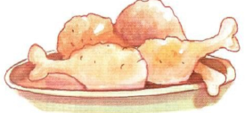 | _______________________
3/ rabe |  | _______________________
4/ oondles | 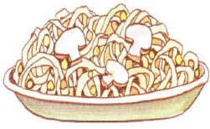 | _______________________

III/ Reorder the words to make correct sentences:(2ms)
1. ‘m / I / hungry /. / |  | _______________________
2. Have / chicken /some / . / |  | _______________________
3 . pillow / my /’s / That / . /
4. quiet! / Shh! / Be |  | _______________________
IV/. Complete:( 2ms)
e
u
o
i


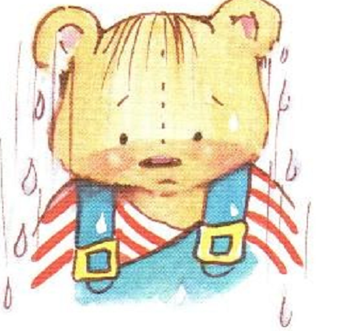

H__t W_t

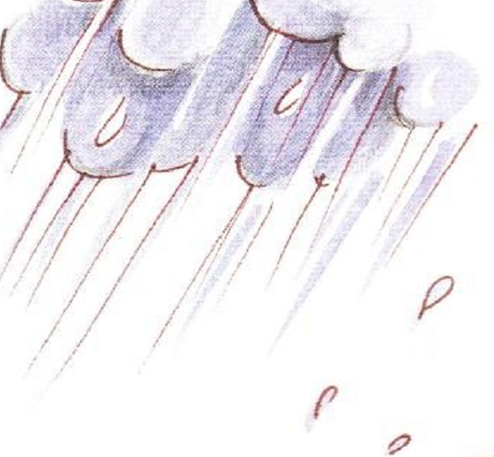


Ra_ning S_nny

V. Match the following.( 2 ms)

1.What’s your name? | a. I’m cool.
2. It is windy. | b . It’s raining.
3. I am hungry. | c .My name is Alan.
4. Hurry up!  1…, 2… , 3 … , 4 … | d . Have some soup.

