2019- 2020( CONT.)
Bài 6: PLAYTIME
I.Matching.

1/ It’s sunny.  2/ I’m hungry.  3/ It’s snowing.  4/ What’s your name?  5/ Play with me!  6/ That’s my pillow.  7/ I want candy.  8/ It’s windy.  9/ Yellow light! | - I’m cool.  - No! it’s my pillow.  - I’m An.  - I’m hot.  - I’m cold.  - Be careful.  - Ok! Let’s swing.  - Have some noodles.  - No, Benny. Not today.
- d, 2…., 3……, 4……, 5 ……..,6……., 7……, 8……, 9…….

II. Reoder.( sắp xếp từ theo tranh)

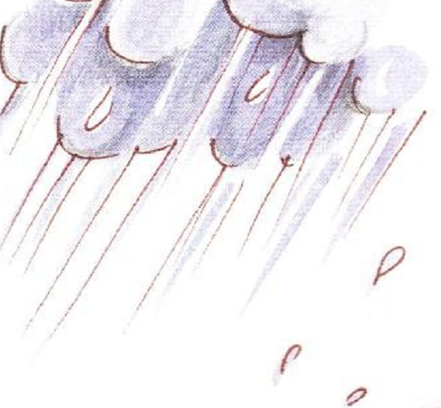

1. It/ raining/ is. ……………………….
wet/ am/ I ……………………….


2. It/ sunny/ is. ……………………….

hot/ am/ I . ……………………….

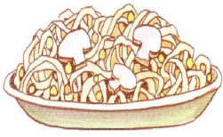

3. am/ I/ hungry. ……………………….

noodles/ some / Have . ……………………….



4. bear/ my/ That/ ‘s / ! ……………………….

No/ my/ That/ ‘s/ !/ . ……………………….
III.PUT IN THE RIGHT ALPHABET.
( XẾP CÁC TỪ THEO ĐÚNG BẢNG CHỮ CÁI)
Red, yellow, pink, green, blue, black, purple, white, gray, orange.
- Black
- ……………
- …………..
- …………..
- …………..
- …………..
- ………….
- …………
- ……………
- ……………
Candy, chips, ice-cream, chicken, noodles, soup, apple, banana, orange.

- Apple.
- …………………..
- …………………..
- ……………………
- ……………………
- …………………..
- …………………..
- …………………..
- …………………

